Analysis

earth peaceful environment research

MOODBOARD:

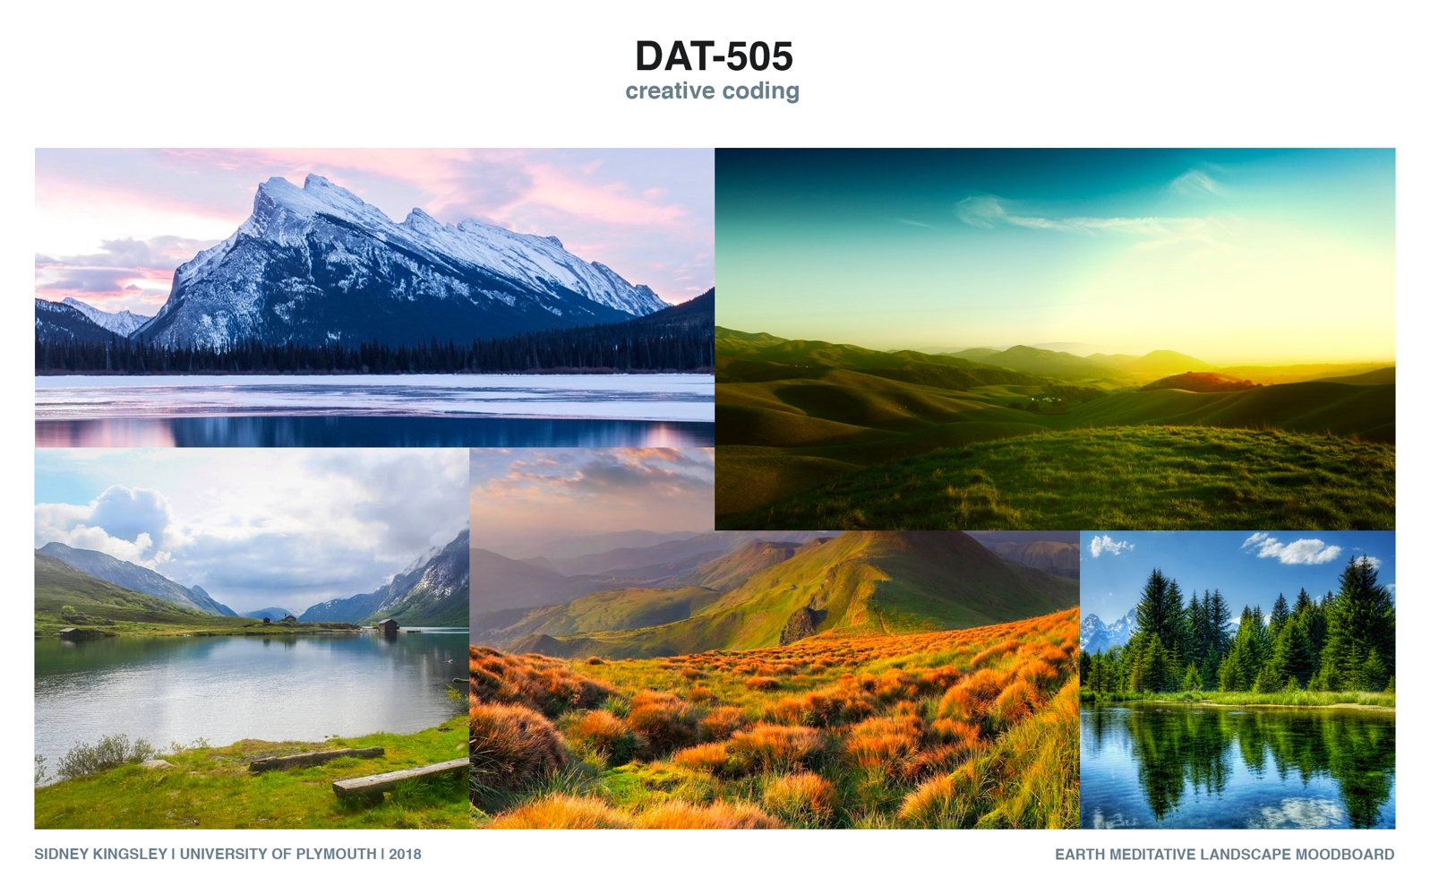ANALYSIS:
To collect these images, I searched “peaceful landscape” into Google. I figured it would be the most efficient, albeit rough, way to deem what people perceived as the relaxing parts of the planet Earth.
At first glance these collected images seem to be quite similar in colour, shape and theme. However, some differences can be seen in these categories. A difference can be found in time of day between these photos, the majority have opted for either morning, or sunset when the colours are softer and more varied, but one has chosen a bright sunny day with a vibrant blue sky. Disregarding this anomalous aspect, every sky depicted contains clouds. This is the inspiration that I will apply to my environment. Mountains, trees and grass also made their way into every photo I came across and will also be included in my product. A slightly less consistent element is water. There is a lake in 3/5 of the found images, which suggests people do generally find lakes calming, it does, however, only seem to be still water. Oceans and rivers were not shown in any search returns.

